 | Tip: | Picture:
Week 1: | Going to a holiday party?  During the holiday season, we tend to go out more and are tempted with things we may not normally eat.  Here are some tips to help you stay on track:  - Offer to bring a healthy dish with you  - Don’t go hungry  - Lead up on the raw veggies  - Don’t stand near the food tables  - Carry water with you at all times | 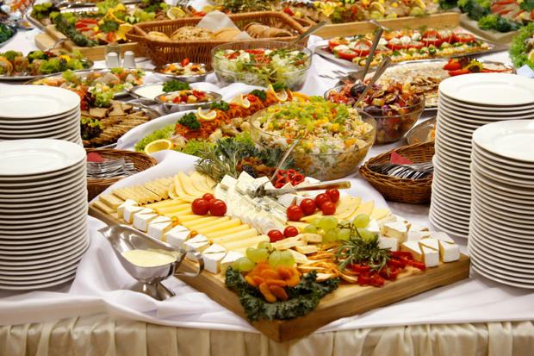
Week 2: | Don’t get stuck in the pumpkin spice latte trap?  Of course, pumpkin anything is delicious! The flavored coffees however are loaded with sugar and fat. For instance, a grande pumpkin spiced latte is 380 calories, 49 grams of sugar & 13 grams of fat. That’s over 12 teaspoons of sugar in one drink!  Check out our website for some delicious pumpkin recipes! | 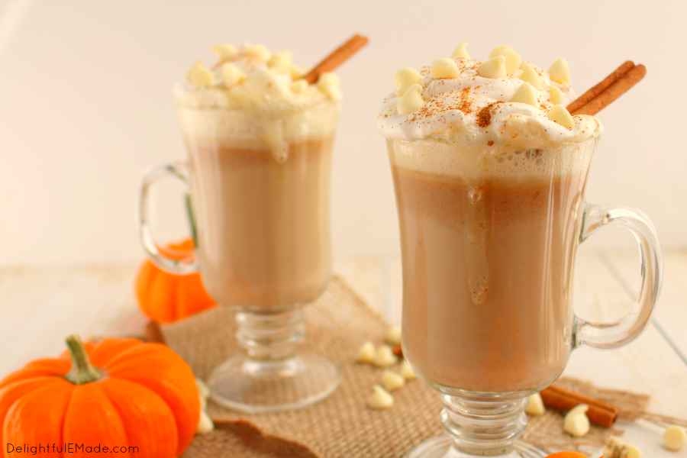
Week 3: | How do you stick with healthy eating when the office kitchen is covered with holiday treats?  Make sure you plan ahead and bring lunch and snacks with you. The moment of weakness comes when you are hungry! Consider raising money for a charity instead of bringing in all the holiday junk food!  Tip: Drink lots of water. Bring in your own healthy treats such as pumpkin protein pancakes, fall flavored greek yogurt or pumpkin spiced RX bars! | 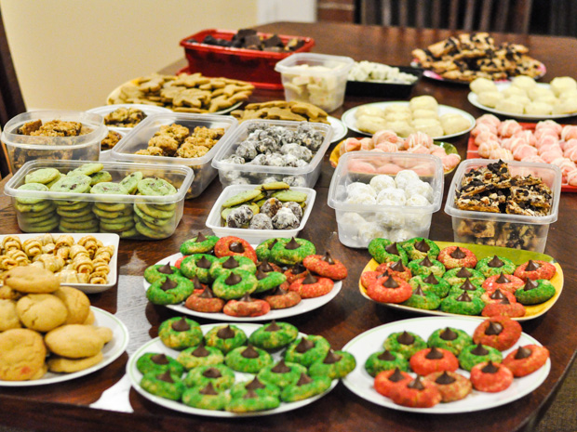
Week 4: | Schedule Your Time to Sweat!  It’s extra important to make time for the gym when we are going out to eat and having a few more treats than normal. Of course, you can’t out-exercise a bad diet but this could help you stay on the right track.  Tip: Plan ahead! If you know you have a holiday party on Friday night, get in the gym Monday- Thursday or try to go in the morning on Friday.

