 | Tip: | Picture:
Week 1: | What is a balanced breakfast?  Breakfast is the most important meal of the day. It is the one meal you should not skip. Having a balanced breakfast will give you the proper energy, to get through the day. The ideal breakfast is balanced with carbohydrates, protein, and healthy sources of fat.  PRO TIP:  Try the 4 ingredient protein pancake from our website. They are easy, delicious, and packed with the nutrition you need. | 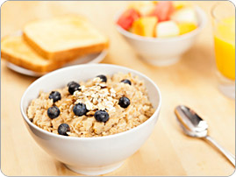
Week 2: | What if I am eating out?  Most restaurant foods are packed with sodium and added fats. Not to mention the oversized portions.  PRO TIP: Order a side of vegetables, ask to substitute a side of fries for a salad with the dressing on the side, and don’t be afraid to ask questions to meet your nutrient needs. | 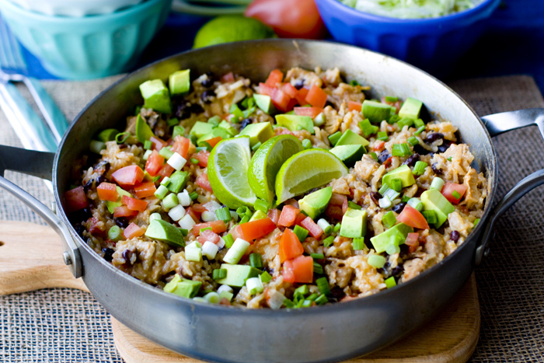
Week 3: | 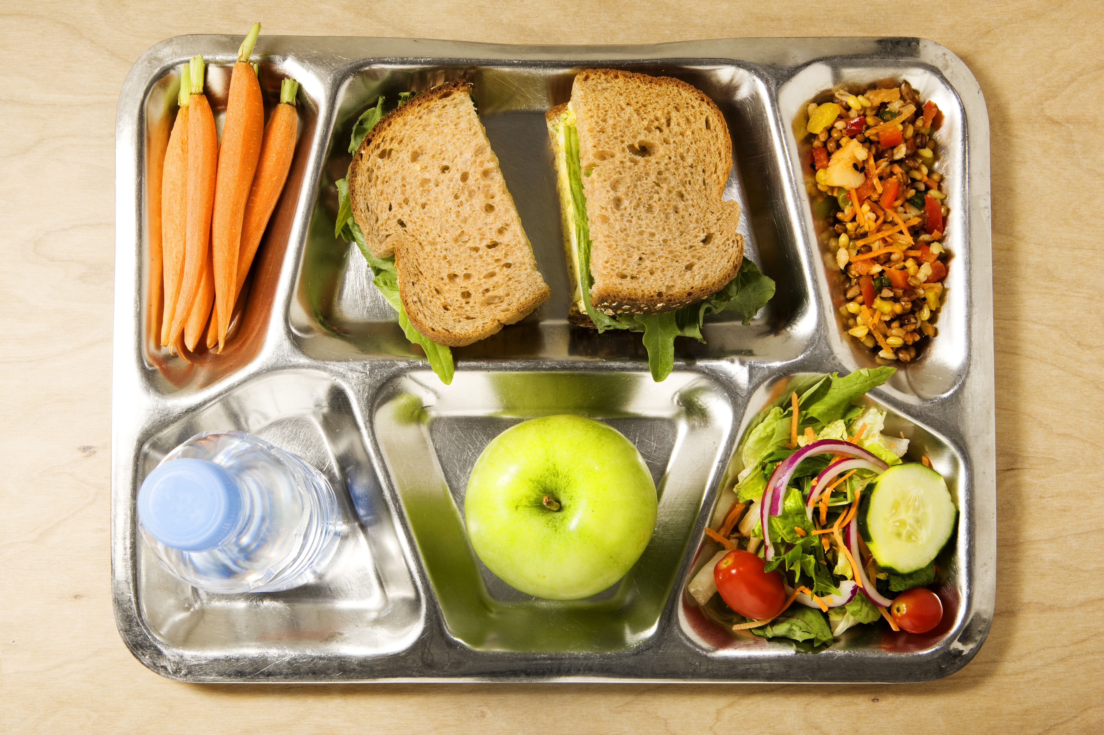  Balanced meals for kids  Most of the quick & convenient foods items for kids are loaded with carbohydrates and sugar. We want to include low sugar snacks, high fiber carbohydrates, lean meats, one vegetable and healthy fats. Stick with water as their beverage.  PRO TIP:  Try a breakfast sandwich with eggs and ham on an Arnold’s sandwich thin!
Week 4: | Balanced Snacks  Snacking is an effective way to fit extra nutrients into your diet and prevent overeating at mealtime. Pair a carbohydrate like, fruits or, low glycemic vegetables with protein foods like nuts for the most balanced snack.  PRO TIP:  Try ½ apple with hard boiled egg or two turkey and hummus rolls ups! | 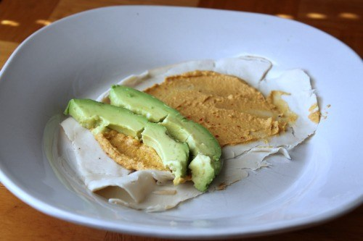

QOD:
Steak or fish? | - Although steak is delicious, it comes with a price. Steaks can contain upwards of 70 grams of fat per 10 ounce serving! That’s more added fat than you would need for the day!  - Try swapping fish out for steak to lower calories and have a more balanced meal.
Sweet or savory? | - Sugar is 8x more addicting than cocaine! The more we have, the more we crave. Try cutting down on the sweets and have a piece of fruit instead.  - Try frozen banana or grapes. Limit yourself to one treat a week.

