 | Tip: | Picture:
Week 1: | When traveling this summer, try to plan ahead! Bring healthy snacks with you to prevent grabbing the convenience gas station food. Pack a little cooler to keep you nourished throughout your trip!  Tip: try packing low sugar kind bars, apple slices and almonds, RX Bars, ham and turkey roll up, rice cake and nut butter or greek yogurt | 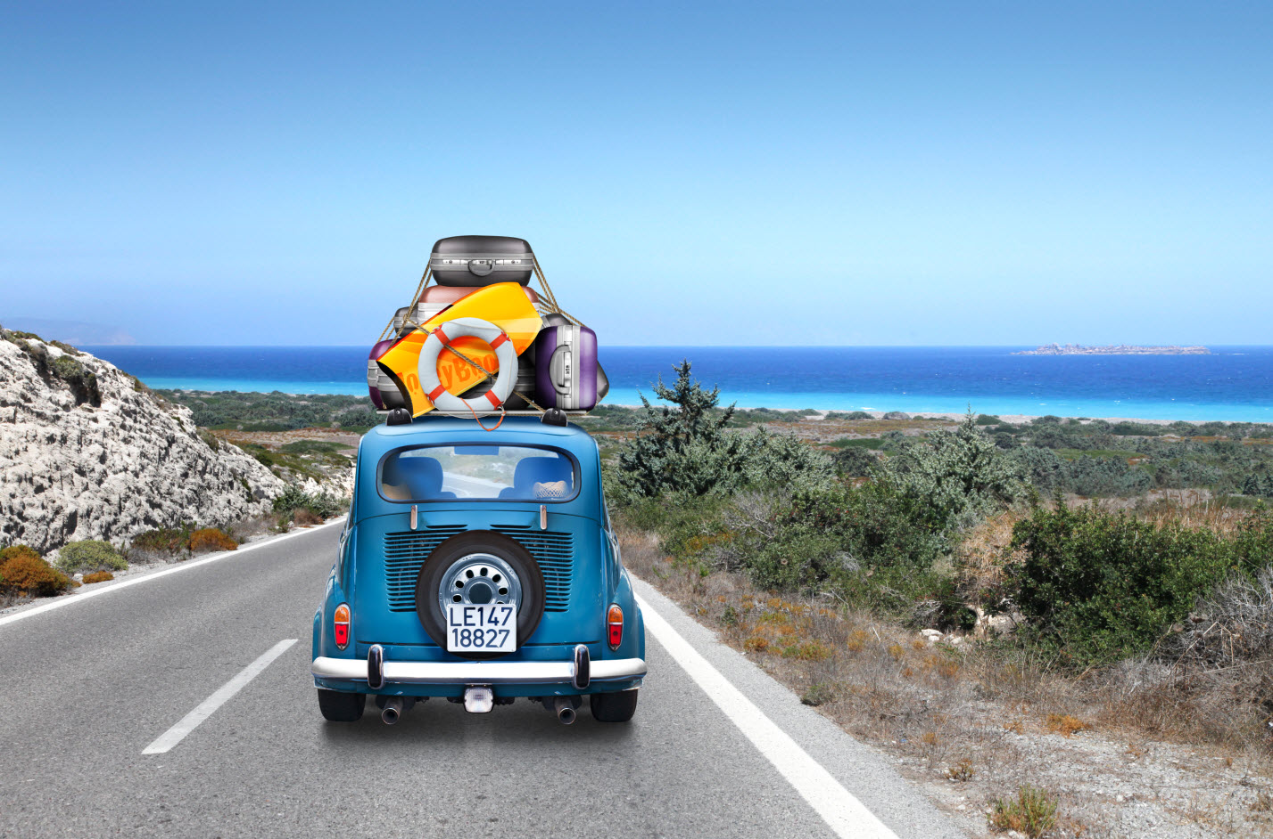
Week 2: | If coffee is your afternoon staple, you may want to reconsider! The half-life of coffee is 8-12 hours; meaning that your afternoon delight is effecting your sleeping patterns in the middle of the night.  Tip: Instead of reaching for your 3pm coffee, grab a glass of ice-cold water and go for a walk to get your blood pumping!
Week 3: | Breakfast is the most important meal of the day! Your glycogen (carbohydrate) stores are the lowest in the morning. Make it count with a balanced meal, including protein, complex carbohydrate and healthy fats. Having a healthy balance breakfast will increase energy levels, improve concentration, prevent you from over eating later in the day and increase performance in the gym!  Tip: Try this amish oatmeal topped with nuts and berries with a hard boiled egg. | 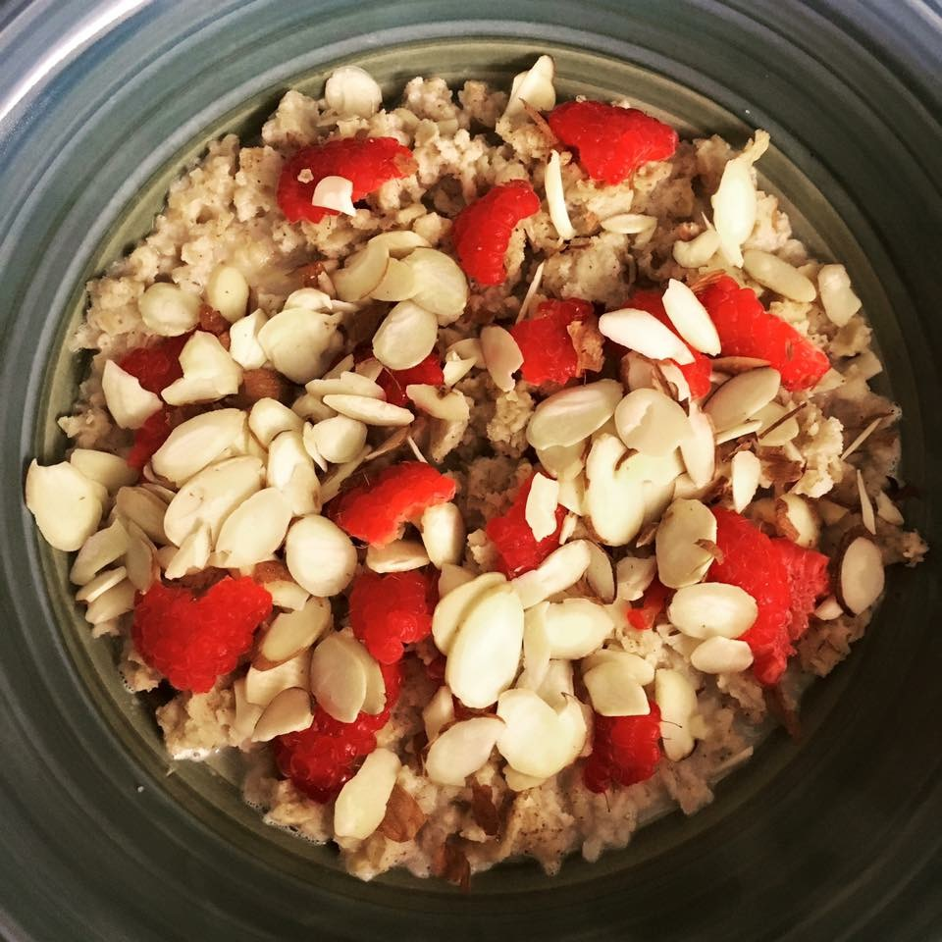
Week 4: | The Skinny on Fat: Your brain lives off of fat. We also need fat to absorb Vitamins A, D, E & K. Plant based sources of fat are a great addition to meals and snacks (in moderation). We just need the right types of fats! Focus on lean meats and getting the majority of the fat in you diet from nuts and seeds.  Tip: add 5-8 almonds to your snack to help balance out your macronutrients and keep your satisfied until your next meal! | 