 | Tip: | Picture:
Week 1: | What are your goals?  Take ownership and write them down. Be realistic. After you set your goals, make a plan on how to achieve them! We can help!
Week 2: | Challenge Yourself!  Sign up for a race/competition or join our nutrition challenge to give you the motivation you need to achieve your goals. Battle of the Boxes Kick Off Seminar January 21st and officially kicks off on January 23d! | OR POST YOUR CHALLENGE FLYER!
Week 3: | Get an accountability partner!  Find yourself a workout buddy and commit to meeting them at the box. Don’t have an accountability partner? We can help!
Week 4: | Tips to achieving your goals:  - Make a Plan  - Track Your Progress  - Staying accountable to yourself by logging your food  - Schedule YOU time in the gym daily | 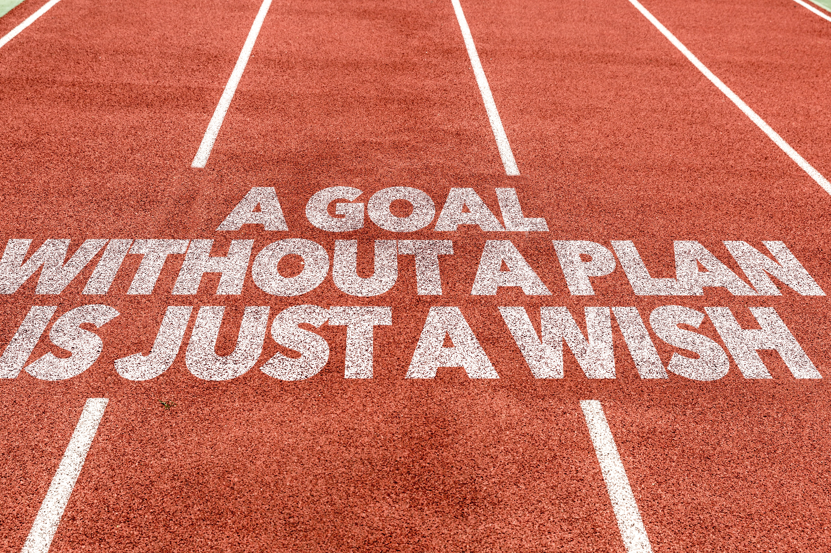

 | Question Of The Day: | Script:
#1: | How much water did you drink today? | Water plays an important role with weight loss and performance. Dehydration leads to decreased metabolism and decreased performance up to 20%. We recommend 80 ounces of water per day!
#2 | What did you eat for breakfast? | Fueling your body before workouts directly effects your performance. For the morning warriors, liquids are preferred over solids and try to have protein + carbs. For everyone else, try to have a balanced breakfast with protein, carbs + healthy fat. Try to stay away from the breakfast cereals loaded with sugar.

